cryptography: the science behind data protection

SUNDAY JOHN OHEPO
(st/cs/nd/21/061)

A SEMINAR PRESENTED TO THE DEPARTMENT OF COMPUTER SCIENCE, SCHOOL OF SCIENCE AND TECHNOLOGY, FEDERAL POLYTECHNIC MUBI, ADAMAWA STATE, NIGERIA

AUGUST, 2023

cryptography: the science behind data protection

SUNDAY JOHN OHEPO
(st/cs/nd/21/061)

A SEMINAR PRESENTED TO THE DEPARTMENT OF COMPUTER SCIENCE, SCHOOL OF SCIENCE AND TECHNOLOGY, FEDERAL POLYTECHNIC MUBI, ADAMAWA STATE, NIGERIA

IN PARTIAL FULFILLMENT OF THE REQUIREMENTS FOR THE AWARD OF NATIONAL DIPLOMA (ND) IN COMPUTER SCIENCE

AUGUST, 2023

Abstract
In the realm of modern cryptography, the demand for secure data processing techniques has surged, driven by the increasing need to perform computations on sensitive information while preserving confidentiality. Homomorphic encryption, a groundbreaking cryptographic paradigm, addresses this challenge by allowing computations to be carried out directly on encrypted data. This paper presents a comprehensive overview of recent advances in homomorphic encryption techniques, highlighting their significance in ensuring data privacy while enabling meaningful data analysis. We delve into various homomorphic encryption schemes, including partially homomorphic, fully homomorphic, and leveled homomorphic encryption, discussing their unique features, computational complexities, and real-world applications. Furthermore, we explore the ongoing research efforts in enhancing the efficiency and practicality of homomorphic encryption, particularly in the context of secure outsourced computation and privacy-preserving machine learning. By shedding light on the cutting-edge developments and future prospects in homomorphic encryption, this paper contributes to a deeper understanding of how cryptographic techniques are reshaping the landscape of secure data processing.

Keywords: Encryption, Secure Data Processing, Cryptographic Techniques, Data Privacy, Computational Complexity.

Introduction
Cryptography is the practice and study of techniques for securing communication and data in the presence of adversaries. It involves the use of mathematical algorithms to convert information into a secure, unreadable format called ciphertext. The primary goal of cryptography is to ensure confidentiality, integrity, authentication, and non-repudiation of information. Cryptography is technique of securing information and communications through use of codes so that only those people for whom the information is intended can understand it and process it. Thus, preventing unauthorized access to information. The prefix “crypt” means “hidden” and suffix “graphy” means “writing”. In Cryptography the techniques which are used to protect information are obtained from mathematical concepts and a set of rule-based calculations known as algorithms to convert messages in ways that make it hard to decode it. These algorithms are used for cryptographic key generation, digital signing, verification to protect data privacy, web browsing on internet and to protect confidential transactions such as credit card and debit card transactions (McGrew & Viega, 2012).
In a world where information flows ceaselessly through the digital arteries of our interconnected society, a paramount challenge emerges – how to safeguard the delicate fabric of data against the lurking threats of prying eyes, malicious actors, and the ever-advancing march of technology. Enter cryptography, the steadfast guardian of our digital realm, a sophisticated dance of mathematical brilliance and algorithmic mastery that weaves an intricate cloak of protection around our most valuable assets. Cryptography, often hailed as the art of secret writing, transcends the mere confines of secrecy. It is the vanguard of data protection, a sentinel of confidentiality, integrity, authentication, and non-repudiation. From the whispered secrets of ancient civilizations to the encrypted transmissions of the digital age, cryptography has been at the forefront of safeguarding sensitive information (Yao, 2021).
Homomorphic encryption, a cryptographic marvel born of mathematical ingenuity, has the astonishing ability to perform computations on encrypted data while preserving its secrecy. This revolutionary technique not only safeguards privacy but also opens the door to secure data analysis, collaborative computing, and outsourcing computations to untrusted parties. As the digital era ushers in an age of data-driven possibilities, homomorphic encryption takes center stage, transforming the very essence of secure computation. At its core, homomorphic encryption embodies the principle of performing mathematical operations on encrypted data, yielding an encrypted result that, when decrypted, corresponds to the result of the operations on the original data. This feat is no small accomplishment, as it combines encryption, computation, and decryption in a symphonic dance that baffles the conventional boundaries of cryptography (Mandell & Stebila, 2019).
As technology hurtles forward, cryptography evolves in tandem, adapting to the new challenges that emerge in an ever-shifting landscape of threats and vulnerabilities. Recent strides in this field have unveiled revolutionary concepts, from homomorphic encryption that lets computations thrive within the sanctum of encrypted data, to the enigmatic world of zero-knowledge proofs, where truths can be unveiled without exposing the underlying facts. These advances are shaping the future of secure communication and data handling, orchestrating an intricate symphony that harmonizes privacy, functionality, and innovation (Brands, 2020).
Literature Review
At the heart of symmetric encryption lies a fundamental principle: a single, secret key known only to authorized parties. This key serves as the linchpin, enabling the transformation of plaintext, or original data, into a seemingly chaotic ciphertext – a cryptic rendition that appears nonsensical to anyone without the key. This metamorphosis ensures that even if unauthorized eyes lay upon the ciphertext, its true meaning remains elusive, locked behind the impenetrable barrier of the secret key. The beauty of symmetric encryption resides not only in its efficacy but also in the intricate dance of algorithms that make it possible. These algorithms, such as the celebrated Advanced Encryption Standard (AES), operate like mathematical enigmas, performing a precisely choreographed sequence of operations that render the plaintext into ciphertext and back again. The symphony of substitution, permutation, and confusion, guided by the symmetrical key, creates a cryptographic ballet where chaos and order coalesce (McGrew & Viega, 2012).
Recent years have witnessed both evolution and refinement in symmetric encryption techniques. The cryptographic community continually pushes the boundaries, seeking to bolster security while preserving efficiency. Techniques like block ciphers, where fixed-size blocks of data are encrypted in parallel, have given rise to modes of operation that enhance security by introducing randomness and counteracting potential vulnerabilities. The influence of symmetric encryption reaches far beyond mere confidentiality. It intertwines with data integrity, providing a shield against unauthorized tampering. It merges with authentication, enabling parties to verify the origin of messages and establish trust. And within the realm of secure communication protocols, symmetric encryption takes center stage, preserving the privacy of data shared between devices, servers, and users (Joye & Quisquater, 2022).
In the sprawling landscape of cybersecurity, where data flows ceaselessly across vast digital highways, the concept of data integrity stands as a stalwart sentinel. Ensuring that data remains unaltered and trustworthy is a paramount concern, and at the heart of this endeavor lies the unassuming yet formidable entity known as hash functions. These cryptographic marvels, operating quietly in the background, play a pivotal role in upholding the sanctity of information, acting as digital fingerprints that validate the authenticity and integrity of data in a world rife with potential threats and vulnerabilities. At their core, hash functions are algorithms that transform variable-length input data into fixed-size output, known as a hash value or digest. This seemingly magical process is non-reversible - given a hash value, it is computationally infeasible to reconstruct the original input data. This unidirectional property forms the basis for their application in data integrity verification and digital signatures. Hash functions serve as the bedrock for data integrity verification. When data is transmitted or stored, its hash value is computed and compared with a previously calculated hash value. If the hash values match, it is highly improbable that the data has been tampered with. Even the slightest alteration in the input data produces a drastically different hash value, making any attempt to manipulate the data readily detectable (Preneel & Oorschot, 2019).
In the sprawling landscape of digital communication, where information traverses vast virtual networks, the concept of trust emerges as a linchpin, binding together interactions and transactions. In this realm, digital signatures stand as an indispensable cornerstone, wielding cryptographic power to authenticate, validate, and secure digital messages, documents, and identities. In the ever-expanding realm of cyberspace, where anonymity and impersonation threaten the very fabric of trust, digital signatures and authentication mechanisms shine as beacons, guiding the way toward a secure and accountable digital future (Turner & Laird, 2020).
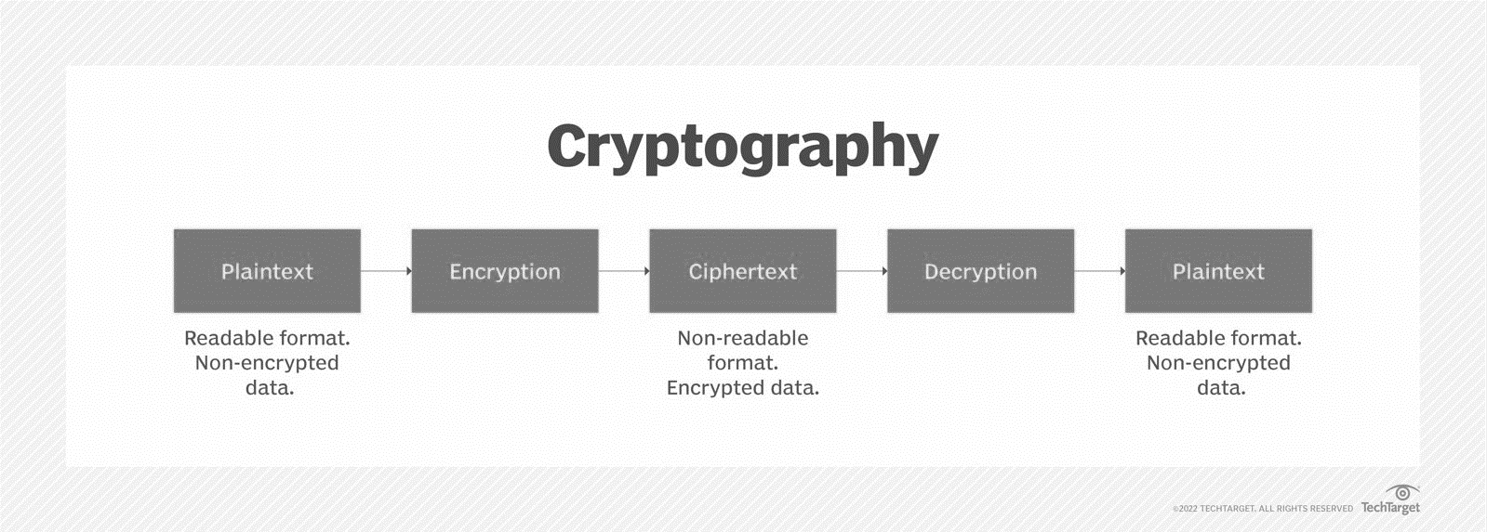
Figure 1: Cryptography block diagram (Turner & Laird, 2020).
At its essence, a digital signature is a virtual seal of authenticity, a cryptographic imprint affixed to a digital entity. The process begins with the generation of a hash value - a compact numerical representation of the original data. This hash value is then encrypted with the private key of the signer, creating the digital signature. Recipients can verify the authenticity of the signature using the corresponding public key, ensuring that the data has not been tampered with since the signature was affixed. Data integrity lies at the core of digital signatures. They ensure that data remains unaltered, confirming the identity of the signer and establishing accountability for the contents of the signed document. In industries where regulatory compliance and legal validity are paramount, digital signatures serve as legal proof of agreement, providing a virtual paper trail that withstands scrutiny. Authentication, the process of confirming the identity of users and entities, finds a formidable ally in digital signatures. Digital signatures bolster authentication mechanisms, granting a higher level of trust and accountability to digital interactions. Public-key infrastructure (PKI) leverages digital signatures to create a web of trust, enabling secure communication between parties who may have never physically met (Schneier, 2017).
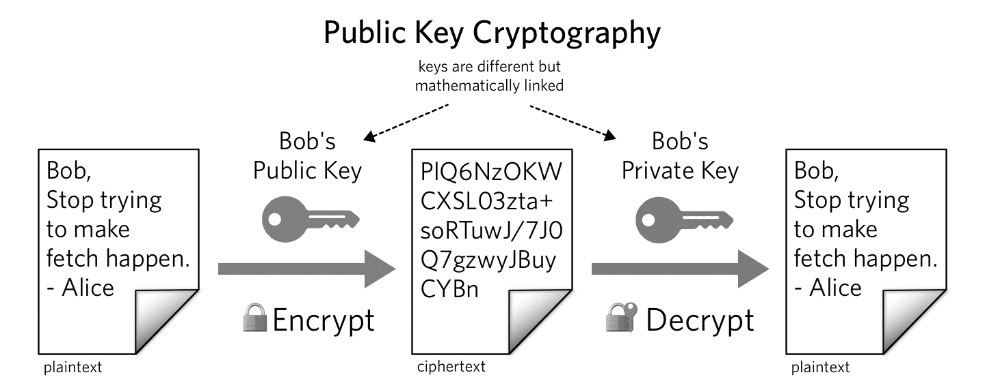
Figure 2: Cryptography depicting public key (Schneier, 2017).
Features of Cryptography: Safeguarding Information in the Digital Realm
In the intricate world of information security, cryptography stands as a resolute guardian, its elegant techniques and mathematical prowess ensuring the confidentiality, integrity, and authenticity of digital data. As a multifaceted discipline, cryptography boasts a spectrum of features that collectively contribute to its indispensable role in the modern digital landscape (Diffie & Hellman, 2018).
Confidentiality: At the core of cryptography lies the fundamental feature of confidentiality. By converting plaintext into ciphertext using encryption algorithms, cryptography ensures that sensitive information remains hidden from unauthorized eyes. Only those possessing the appropriate decryption key can transform the ciphertext back into its original form (Diffie & Hellman, 2018).
Detecting Tampering: Cryptography bolsters data integrity by enabling the creation of digital signatures and message authentication codes. These cryptographic constructs act as virtual seals, confirming that data has not been altered or tampered with during transmission or storage. If any modification occurs, the signature or code becomes invalid, signaling potential foul play (Diffie & Hellman, 2018).
Authentication: Cryptography facilitates robust authentication mechanisms, verifying the identity of users, devices, and entities in the digital realm. Through the use of digital certificates, public-key infrastructure (PKI), and asymmetric encryption, cryptography ensures that parties can confidently trust the sources and recipients of information (Diffie & Hellman, 2018).
Ensuring Accountability: Digital signatures play a crucial role in non-repudiation, making it nearly impossible for signers to deny their involvement in a transaction or communication. This feature is invaluable in legal contexts, where parties must be held accountable for their digital actions (Diffie & Hellman, 2018).
Safeguarding Access: Effective key management is a cornerstone of cryptography. Cryptographic keys, whether symmetric or asymmetric, must be generated, distributed, and stored securely. Key management protocols ensure that only authorized users can access encrypted data and perform cryptographic operations (Diffie & Hellman, 2018).
Access Control: Cryptography supports access control by enabling data encryption and decryption based on user roles and permissions. Data can be encrypted with keys tied to specific user attributes, ensuring that only authorized individuals can access sensitive information (Diffie & Hellman, 2018).
Privacy Preservation: Cryptography empowers individuals to protect their privacy by encrypting personal data. This is particularly relevant in scenarios involving sensitive personal information, such as medical records, financial data, and communications (Diffie & Hellman, 2018).
Secure Communication: Cryptography safeguards data during transmission across networks by encrypting it before sending and decrypting it upon arrival. This feature ensures that even if intercepted by malicious actors, the intercepted data remains incomprehensible (Diffie & Hellman, 2018).
Types of Cryptography
Symmetric Key Cryptography: It is an encryption system where the sender and receiver of message use a single common key to encrypt and decrypt messages. Symmetric Key Systems are faster and simpler but the problem is that sender and receiver have to somehow exchange key in a secure manner. The most popular symmetric key cryptography system is Data Encryption System (DES) and Advanced Encryption System (AES) (Paar & Pelzl, 2010).
Hash Functions: There is no usage of any key in this algorithm. A hash value with fixed length is calculated as per the plain text which makes it impossible for contents of plain text to be recovered. Many operating systems use hash functions to encrypt passwords (Brands, 2020).
Asymmetric Key Cryptography: Under this system a pair of keys is used to encrypt and decrypt information. A receiver’s public key is used for encryption and a receiver’s private key is used for decryption. Public key and Private Key are different. Even if the public key is known by everyone the intended receiver can only decode it because he alone know his private key. The most popular asymmetric key cryptography algorithm is RSA algorithm (Brands, 2020).
Applications of Cryptography
Computer passwords: Cryptography is widely utilized in computer security, particularly when creating and maintaining passwords. When a user logs in, their password is hashed and compared to the hash that was previously stored. Passwords are hashed and encrypted before being stored. In this technique, the passwords are encrypted so that even if a hacker gains access to the password database, they cannot read the passwords (Boneh & Franklin, 2018).
Digital Currencies: To safeguard transactions and prevent fraud, digital currencies like Bitcoin also use cryptography. Complex algorithms and cryptographic keys are used to safeguard transactions, making it nearly hard to tamper with or forge the transactions (Boneh & Franklin, 2018).
Secure web browsing: Online browsing security is provided by the use of cryptography, which shields users from eavesdropping and man-in-the-middle assaults. Public key cryptography is used by the Secure Sockets Layer (SSL) and Transport Layer Security (TLS) protocols to encrypt data sent between the web server and the client, establishing a secure channel for communication (Boneh & Franklin, 2018).
Electronic signatures: Electronic signatures serve as the digital equivalent of a handwritten signature and are used to sign documents. Digital signatures are created using cryptography and can be validated using public key cryptography. In many nations, electronic signatures are enforceable by law, and their use is expanding quickly (Paar & Pelzl, 2010).
Authentication: Cryptography is used for authentication in many different situations, such as when accessing a bank account, logging into a computer, or using a secure network. Cryptographic methods are employed by authentication protocols to confirm the user’s identity and confirm that they have the required access rights to the resource (Boneh & Franklin, 2018).
Cryptocurrencies: Cryptography is heavily used by cryptocurrencies like Bitcoin and Ethereum to safeguard transactions, thwart fraud, and maintain the network’s integrity. Complex algorithms and cryptographic keys are used to safeguard transactions, making it nearly hard to tamper with or forge the transactions (Stinson, 2005).
End-to-End Encryption: End-to-end encryption is used to protect two-way communications like video conversations, instant messages, and email. Even if the message is encrypted, it assures that only the intended receivers can read the message. End-to-end encryption is widely used in communication apps like WhatsApp and Signal, and it provides a high level of security and privacy for users (Paar & Pelzl, 2010).
Advantages and Disadvantages of Cryptography
Cryptography, a powerful tool in the arsenal of information security, bestows numerous benefits while also presenting challenges. Its ability to protect data and communications from unauthorized access is evident, yet its complexity and potential vulnerabilities demand careful consideration.
Advantages Disadvantages of Cryptography
Data Security: The primary advantage of cryptography is its ability to secure sensitive data, ensuring that only authorized individuals with the appropriate cryptographic keys can access and decrypt the information.
Confidentiality: Cryptography guarantees the confidentiality of data, preventing unauthorized parties from understanding the content of encrypted messages even if they intercept them.
Integrity Assurance: Cryptographic techniques enable the detection of data tampering. Hash functions and digital signatures provide a means to verify the integrity of data during transmission and storage.
Authentication and Non-Repudiation: Cryptography supports robust authentication mechanisms, confirming the identity of users and entities. Digital signatures ensure accountability, making it difficult for parties to deny their actions.
Secure Communication: Cryptography safeguards the privacy of communications, enabling secure transmission of sensitive information over potentially insecure channels.
Access Control: Cryptography contributes to access control by encrypting data based on user roles and permissions, ensuring that only authorized individuals can access specific information.
Global Applications: Cryptography is a universal tool with applications spanning industries, from financial transactions to healthcare, military operations, e-commerce, and beyond.
Quantum Readiness: Cryptographers are actively working on quantum-resistant algorithms to ensure the continued security of data in a future era of quantum computing.
Disadvantages of Cryptography
Complexity: Cryptography can be intricate, requiring specialized knowledge to implement and manage properly. Misconfigurations or errors in implementation can lead to vulnerabilities.
Key Management: Effective key management is crucial, and losing cryptographic keys can result in permanent data loss or compromised security.
Performance Overhead: Encrypting and decrypting data introduces computational overhead, potentially slowing down data processing and communication speed.
Resource Consumption: Cryptographic operations demand computational resources, which can be a concern in resource-constrained environments such as embedded systems or IoT devices.
User Experience: In some cases, cryptographic protocols can introduce complexity and friction into user experiences, potentially leading to user resistance or errors.
Key Exchange and Distribution: Securely exchanging and distributing cryptographic keys between parties can be challenging, especially in scenarios involving a large number of participants.
Vulnerabilities and Attacks: While cryptography provides security, it is not immune to vulnerabilities and attacks. Flaws in algorithms, implementation errors, and evolving attack methods require constant vigilance and updates.
Quantum Threat: While quantum-resistant cryptography is being developed, the advent of quantum computers could potentially compromise the security of existing cryptographic systems.

Conclusion
In the ever-expanding digital landscape, where information flows ceaselessly and the boundaries between privacy and vulnerability blur, cryptography emerges as a steadfast guardian, weaving a cloak of protection around our most valuable assets. Its multifaceted features, ranging from confidentiality to authentication, empower individuals and organizations to navigate the intricate world of data security with confidence. As we traverse the currents of technology, cryptography stands as an unyielding beacon, illuminating the path toward a future where privacy, integrity, and authenticity remain unwavering values.
Recommendations
- Keep abreast of the latest advancements and best practices in cryptography. Regularly update your knowledge to align with emerging threats and vulnerabilities.
- Cryptography is intricate, and proper implementation is paramount. Engage experienced professionals or teams to ensure secure design, deployment, and maintenance.
- Prioritize robust key management practices. Safeguard cryptographic keys, rotate them regularly, and consider using hardware security modules (HSMs) for added protection.
- Security Audits: Conduct regular security audits to identify and rectify vulnerabilities in your cryptographic systems. Employ third-party experts to assess your infrastructure and provide valuable insights.
- Educate users about the importance of secure practices, such as safeguarding their private keys and understanding the risks of phishing attacks.
- Strive for a balance between security and usability. While cryptographic mechanisms enhance protection, consider user experience to avoid unnecessary complexity.

References
Boneh, D. & Franklin, F (2018). Identity-Based Encryption from the Weil Pairing. SIAM Journal on Computing, 32(3), 11-17.
Brands, S. (2020). Rethinking Public Key Infrastructures and Digital Certificates: Building in Privacy. MIT Press, New York.
Diffie, W. & Hellman, M. (2018). New directions in cryptography. IEEE Transactions on Information Theory, 22(6), 76-91.
Joye, M. & Quisquater, J. (2022). Efficient computation of full ecdsa signature and verification on the ecbp curve. IACR Transactions on Cryptographic Hardware and Embedded Systems, 5(1), 14-23.
Mandell, F. & Stebila, C. (2019). LadderLeak: Breaking ECDSA with Less Than One Bit of Nonce Leakage. USENIX Security Symposium, 12(1), 34-67.
McGrew, D. & Viega, J. (2012). The Security and Performance of the Galois/Counter Mode (GCM) of Operation. ACM Transactions on Information and System Security, 15(1), 45-57.
Paar, C., & Pelzl, J. (2010). Understanding cryptography: A textbook for students and practitioners. Springer Science & Business Media.
Preneel, B. & Oorschot, V. (2019). On the Security of Two MAC Algorithms. Advances in Cryptology, 4(2), 13-25.
Schneier, B. (2017). The Need for Public Key Infrastructure. Computer Security, 30(6), 97-107.
Stinson, D. R. (2005). Cryptography: Theory and practice (3rd ed.). CRC Press.
Turner, S. & Laird, D. (2020)."Requirements for Modeling and Analyzing Software Safety and Security. IEEE Transactions on Software Engineering, 30(9), 20-34.
Yao, A. (2021). Protocols for Secure Computations. Proceedings of the 23rd Annual ACM Symposium on Theory of Computing, 19(1), 1-9.

